Mini Vortex Mixer—MIX1000
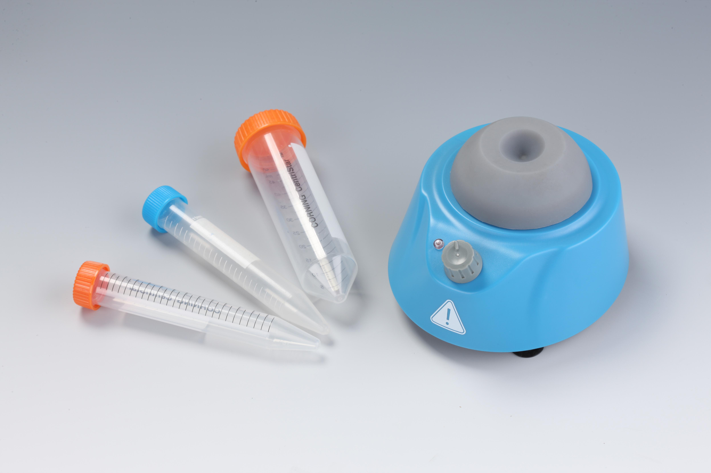
Description:
MIX1000 Mini Vortex Mixer is designed for “touch” mixing a variety of test tubes. With a 4.5mm orbit and adjustable speed of 1000-2800rpm, the mini vortex mixer instantly vortexes even the largest samples, including nearly full 50ml tubes. The small footprint allows it to be used on even the most crowded bench.

Features:
- Shaking speed: 1000-3500rpm.
- Powerful and reliable motor designed for daily laboratory use.
- “Touch” pressure activated operation.
- Accept a variety of test tubes, including the tubes up to 50ml.
- Mini-sized, allowing it to fit on even the most crowded bench.

Parameters:
Model | MIX1000
Speed | 1000-3500rpm
Type of motor activation | Touch pressure activated operation
Type of movement | Orbital
Orbit | 4.5mm
Max test tube size | Ф30mm
Max load | 0.1kg
Voltage | AC100-240V, 50/60Hz
Power | 24W
Dimension(mm) | 125×115×76
Weight(kg) | 0.55

